REGISTRATION OF PARTICIPANTS
Dear colleagues!
If you plan to participate in the conference, please complete the following
1. Fill out and send the conference participant questionnaire by e-mail:
Full Name________________________________________________
Scientific degree, academic title_______________________________
Place of work, position______________________________________
E-mail; Contact phone number_______________________________
Date and time of arrival and departure__________________________
I plan to: publish an article and receive a collection 
deliver a report 
to present an exposition of their developments 
2. List the organizational contribution in the amount of: 300 hryvnias. for citizens of Ukraine; 50 euros for citizens of other countries
This amount will be transferred to the account of the Charitable Organization "KNUBCA Development Fund" and will be used to pay for the publication of conference materials, provide each participant with a set of theses of reports and scientific works, souvenir products, organization of coffee breaks, as well as for technical support of the conference. Approximate cost of accommodation and food - 700 UAH. per day
3. Email paper abstracts, article and speech presentation for publication. The volume of theses is 0.05-0.1 author. sheet (2-4 thousand printed characters), text without annotation, tables, figures, formulas and references to literature. Information about the authors is provided in full. The rules for writing articles are given on the conference website https://www.knuba.edu.ua/faculties/fise/ecology-resource-energy/

MAIN TERMS AND ADDRESSES ACCEPTANCE OF QUESTIONNAIRES - until November 12, 2023. On e-mail: water-knuba@ukr.net

RECEIVING CONTRIBUTIONS -until November 12, 2023.
Одержувач: Благодійна організація «Фонд розвитку Київського національного університету будівництва та архітектури (КНУБА)»; ЄДРПОУ: 38675230; МФО: 320649; ПАТ КБ «Приватбанк»
р/р UA863052990000026009035020297
Призначення платежу "Добровільне пожертвування для виконання статутних задач"

For payment issues, contact:
+38(044) 245-42-26 Victoria SHOVKIVSKA

ACCEPTANCE OF ARTICLES - until November 12, 2023.
e-mail: water-knuba@ukr.net
THE CONFERENCE IS SUPPORTED
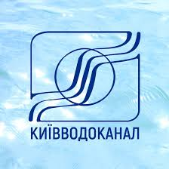

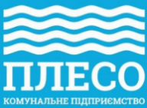

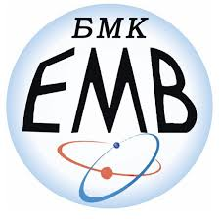

INFORMATION SUPPORT
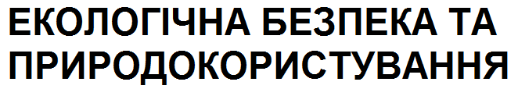

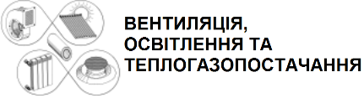

Ukraine
KYIV
22-24
NOVEMBER
2023

INVITATION
PARTICIPATE

IN THE SCIENTIFIC AND EXHIBITION PROGRAM OF THE INTERNATIONAL SCIENTIFIC AND PRACTICAL CONFERENCE

ECOLOGY
RESOURCE
ENERGY 2023

MULTIFUNCTIONAL
ENERGY AND RESOURCE EFFICIENT
ENVIRONMENTALLY SAFE TECHNOLOGIES
IN ARCHITECTURE, CONSTRUCTION AND RELATED SECTORS OF THE ECONOMY

KYIV NATIONAL UNIVERSITY OF CONSTRUCTION AND ARCHITECTURE, UKRAINE
WARSAW UNIVERSITY OF TECHNOLOGY, POLAND
LUBLIN UNIVERSITY OF TECHNOLOGY, POLAND
CZENSTOCHOW UNIVERSITY OF TECHNOLOGY, POLAND
CO-ORGANIZERS
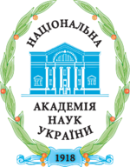
NATIONAL ACADEMY OF SCIENCES UKRAINE
POLISH ACADEMY OF SCIENCES

With the participation of: Yevhen Paton Electric Welding Institute; Institute of Superhard Materials; Institute of Technical Thermophysics; Gas Institute; Institute of Magnetism.

MANAGEMENT OF THE CONFERENCE
Petro Kulikov, rector of KNUCA, Ukraine - Chairman
Oleksandr Priymak, dean of faculty, KNUCA, Ukraine -
Deputy Chairman

SCIENTIFIC COMMITTEE
Boris Basok – Ukraine; Maria Walery – Poland; Aleksey Vasiliev – USA; Olena Voloshkina – Ukraine; Givi Gavardashvili – Georgia; Valentin Hlyva – Ukraine; Mykola Gomelya – Ukraine; Stepan Epoyan – Ukraine; Vasyl Zhelykh – Ukraine; Gennady Zhuk – Ukraine; Oleksandr Kovalchuk – Ukraine; Gennady Kochetov – Ukraine; Tetyana Kryvomaz – Ukraine; Mykola Krupa – Ukraine; Mykola Kuz – Ukraine; Valery Makarenko – Ukraine; Serhiy Maksymov – Ukraine; Margaryan Artur – Armenia; Serhii Martynov – Ukraine; Viktor Mileikovskyi – Ukraine; Mustafa Mustafayev – Azerbaijan; Nurtaҫ Öz – Turkey; Andrzej Osiadacz – Poland; Janina Piekutin – Poland; Konstantin Predun – Ukraine; Tatiana Prikhna – Ukraine; Yaroslav Romaniuk – Switzerland; Henryk Sobczuk – Poland; Tetyana Tkachenko – Ukraine; Adam Ujma – Poland; Malgorzata Ulewicz – Poland; Natalia Fialko – Ukraine; Maciej Chaczykowski – Poland; Soraya Heuss-Aßbichler – Germany; Viktor Khoruzhiy – Ukraine; Tomasz Cholewa – Poland, Jacek Czerwinski- Poland.

ORGANIZATIONAL COMMITTEE
Oleksandr Priymak (head), Gennadiy Kochetov, Tetyana Argatenko, Viktoriya Konovalyuk, Olena Dupliak, Iryna Klimova, Yuriy Kopanytsia, Dmytro Samchenko, Viktoriya Shovkivska, Artem Honcharenko.

OBJECTIVES OF THE CONFERENCE
• Researching trends in the development of energy efficiency of the latest industrial and utility technologies, rational use of natural resources and environmental protection.
• Providing a platform for the exchange of ideas and experience in the development and implementation of innovative materials and technologies between scientists and practitioners in the field of nature and resource use.
• Development of cooperation between scientists, technology developers, domestic and foreign investment companies. Development of joint projects and programs, establishment of business contacts and commercial relations.
• Exchange of experience in the field of legal regulation, economics and management from the implementation and operation of energy-saving technologies and efficiency in nature management.

SCIENTIFIC TOPICS
• Environmental efficiency. Rational use of nature and sustainable development.
• Global climate changes. Man-made influences. Management of ecosystems.
• Water supply and drainage of communal and industrial facilities.
• Technologies and utilization of industrial waste.
• Organic, nuclear and alternative fuels.
• Production and use of thermal energy. Heating and gas supply.
• Non-traditional and renewable energy.
• Biosphere-compatible engineering microclimate provision of technologies and buildings with near-zero energy consumption.
• Energy saving and energy efficiency.
• Intelligent control and automation systems.
Fundamental and applied scientific research. Highly efficient design, installation, construction and operation.
Digitization, artificial intelligence and cyber security.
National and international policy on ecology, resources and energy.

REGULATIONS ON THE CONFERENCE
• Registration of participants -11/22/2023, 9:00 a. m
• Conference opening - 11/22/2023 at 10:00 a. m
• Plenary session - 11/22/2023 from 10:00 to 17:00 with a break at 13:00-14:00
• Sectional meetings - November 23 and 24, 2023 from 10:00 a.m.
• Between meetings, there is a coffee break
• Round table based on the results of the conference - 11/24/2023 at 2:00 p. m
It is possible to participate online on the Zoom platform.

EXPOSURE PROGRAM
During the conference, participants will be given the opportunity to present scientific-technical, scientific-methodical and industrial developments.

LANGUAGES OF THE CONFERENCE: UKRAINIAN, ENGLISH

RULES FOR DESIGN OF ARTICLES
Depending on the topic, the article will be published in one of the scientific and technical collections included in the List of scientific and specialized publications of Ukraine (category "B"): "Ventilation, lighting and heat and gas supply" http://vothp.knuba.edu.ua/, " Problems of water supply, drainage and hydraulics" http://wateruse.org.ua/, "Ecological safety and nature management "http://es-journal.in.ua/, “Gas, water and Sanitary Technology” http://gazwoda.pl/. Materials for publication should be sent to e-mail water-knuba@ukr.net as an attached file. The requirements for design and submission of manuscripts are submitted on the conference website https://www.knuba.edu.ua/faculties/fise/ecology-resource-energy/ and on the websites of magazines.
Each participant of the conference (if desired) will receive a certificate.

QUESTIONS REGARDING THE CONFERENCE
+380442454844; +380503398494
Prof. Oleksandr PRYIMAK
+380442415530
Prof. Gennady KOCHETOV

